

**AMP Automate User Certification**

**Deployment Guide**

10/25/2021



|  |  |  |  |  |  |
| --- | --- | --- | --- | --- | --- |
|  | | | | | |
| Deployment Guide | | | | | |
| Doc.Code: | AMP Automate User Certification - Deployment Guide | | | | |
| Effective Date: | 10/30/2021 |  |  |  |  |
|  |  |  |  |  |  |

Table of Contents

1. Purpose 4

2. Scope 4

3. Pre-Requisites 4

DB Set up 4

4. SSIS Package set up 5

5. Code Repository 9

6. Code Movement 9

7. Application configuration 9

8. ConnectDirect Real time Feed Configuration 9

9. ConnectDirect Real time Feed Job Scheduling 10

10. Appendix 13

11. Assumptions 13

12. Revision History 13

1. Purpose

This deployment guide provides the instructions for deploying and configuring AMP (Access Management Portal) Application that was developed as part of AMP Automate User Certification Project on production environment.

1. Scope

The scope of this guide is limited to deployment of AMP portal Source code, software and database assets and configurations, as applicable.

1. Pre-Requisites

Following list of software’s are required as prerequisite to run AMP Portal.

* Visual Studio Code (Latest available version)
* MS.net framework 4.7.2
* Dot Net 5 (core)
* MS Visual studio- 2019 Professional
* SQL Server 2016 with SQL server integration services
* Node JS (Latest available version)
* Angular 10 CLI and Angular material

For Infrastructure Set up and details required for set up of AMP Portal, please refer to Project - Architecture and Design Document:

* GLX – AMP Automate User Certification_Architecture and Technical Design Document v2.0_31Aug.docx

1. Deployment Servers

The Final list of deployment servers to be provided by Steve M and Approved by Jill Billings

* AMPWEB01
* AMPWEB02
* AMPAPP01
* AMPAPP02
* AMPDB1
* AMPDB2
* AMPDR1

1. DB Set up

Following steps to be followed in order to setup Database required for AMP Portal

**Step1:** Install SQL server 2016

**Step2:** Configure File Table Permission in SQL server Configuration Manager as shown below

**Step 4:** Create DB owner, Application User (AMP UI), Service user (SSIS) for AMP Database

**Step 5:** Create AMP Database and grant Read /write permissions to Application User, Service User and DB Owner

**Step 6:** Execute the Database Scripts in give sequence order for creating schema, Schema constraints, Store Procedure, Views, User defined functions, file tables and indexes from below share path

**Step7:** Configure SFTP for Workday. Please Refer **Appendix A**

Code Repository here: <https://escmstash.1dc.com/projects/AMP>/Database

Note: All Firewalls required to be open for Standard ports to work for SQL server and SSIS

1. SSIS Package set up

For Deploying AMP SSIS Packages and scheduling jobs using SQL Agent, follow step by step instructions provided below:

SSIS Packages are deployment using SSIS Catalogs system

**Step 1:** Open SSMS

**Step 2**: Right click on integration services catalogs then create catalog folder

**Step 3:** Create SSISDB

**Step 4:** Create Project for each Environment

**Step 5:** Create OLEDB connection string (SQL server)

**Step 6**: Create Excel Connection string

**Step 7:** Assign variable for each SSIS Package

|  |  |
| --- | --- |
| Variable Name | Values |
| SourceFolder | E:\Data\Incoming\SSIS\DEV\ArcherAMP |
| SourceFolderFullPath | @[User::SourceFolder]+"\\"+ @[User::FileNamewithExtension] |
| ArchiveFolder | E:\Data\Incoming\SSIS\DEV\ArcherAMP |
| Archive FolderFullPath | @[User::ArchiveFolder]+ "\\"+@[User::FileName]+ (DT_WSTR,4)DATEPART("yyyy",GetDate()) +  RIGHT("0" + (DT_WSTR,2)DATEPART("mm",GetDate()) ,2) +  RIGHT("0" + (DT_WSTR,2)DATEPART("dd",GetDate()),2) + "_" +  RIGHT("0" + (DT_WSTR,2)DATEPART("hh",GetDate()),2)+  RIGHT("0" + (DT_WSTR,2)DATEPART("mi",GetDate()),2) + ".xlsx" |
| FileName | ACG_RFDs_GalaxE_RawData_v1 |
| FileNameWith Extension | ACG_RFDs_GalaxE_RawData_v1.xlsx |

**Step 8:** Build Project Successfully

**Step 9:** Once project created, Right click on the project and deploy the packages

1.Open the wizard, click Next

**2. Select Source :**Select SSIS Project model, Project Path and click next

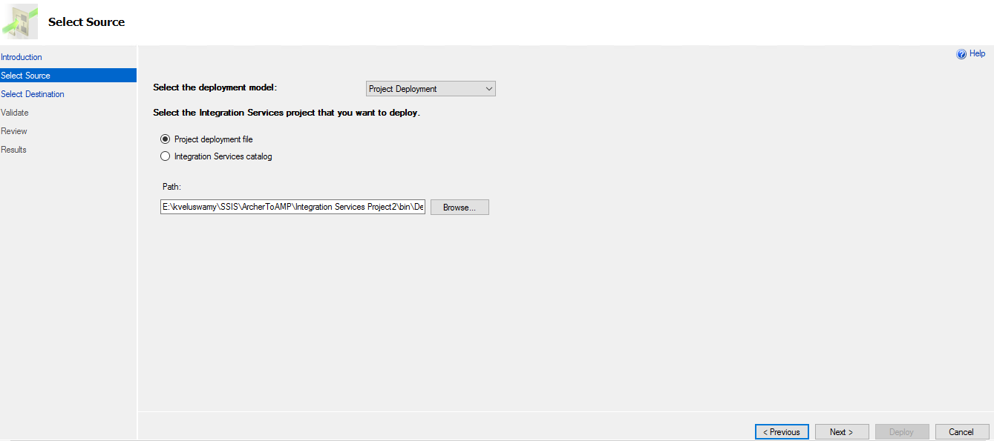

**3. Select destination:** Connect to Database with Windows Authentication and create new Project folder under SSISDB catalog

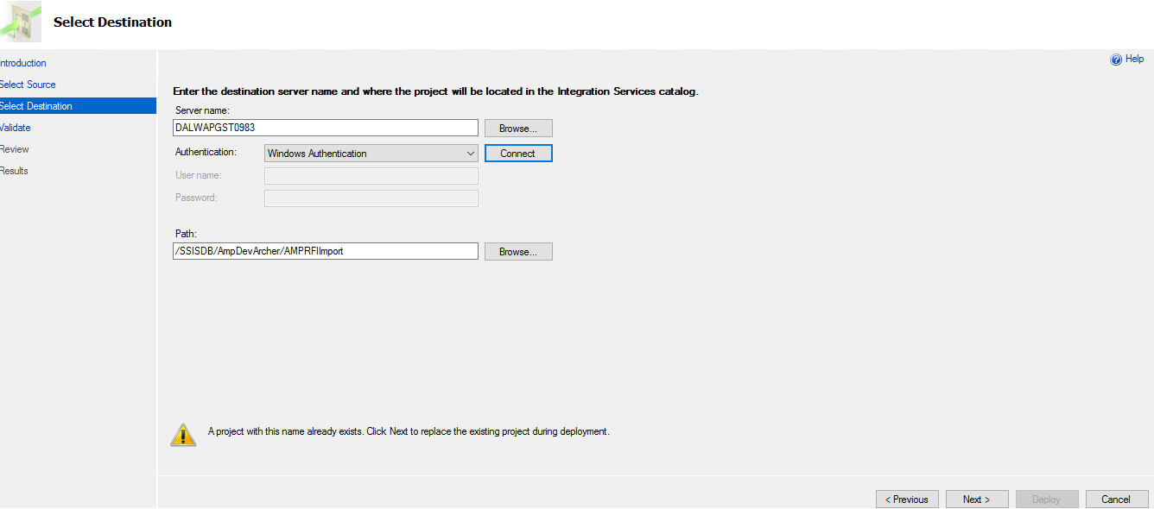

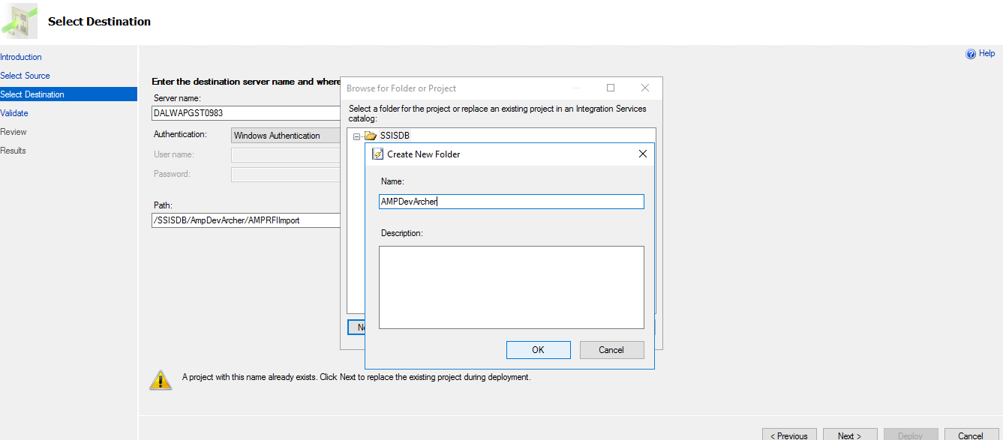

**4. Validation and CLICK NEXT**

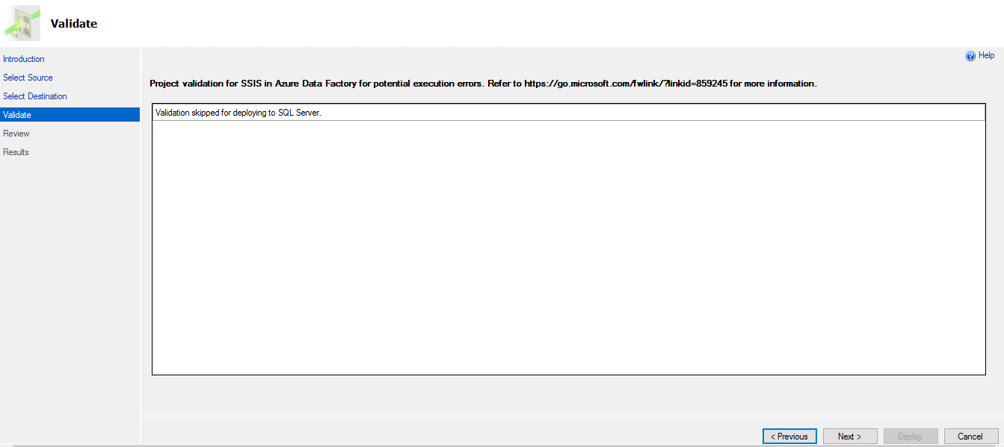

**5. Review your selection and click on Deploy**

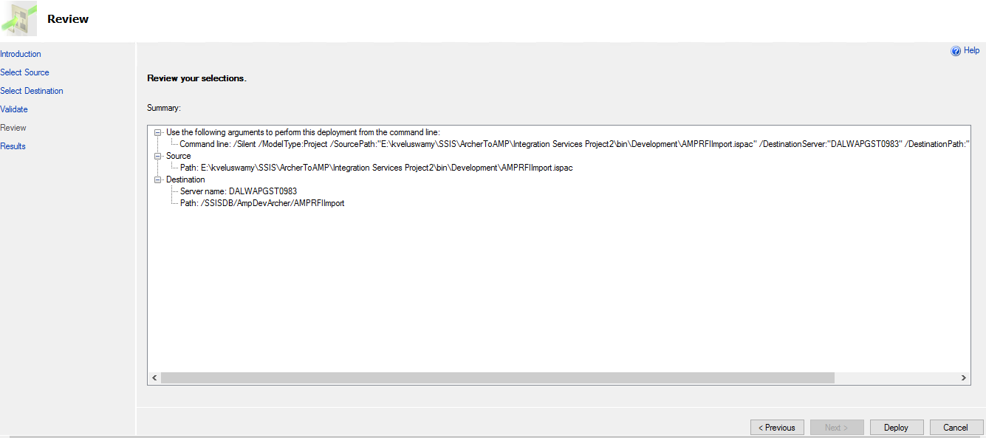

**6.Deployment results will be shown**

**7.CrossVerify in Database under intergration service**

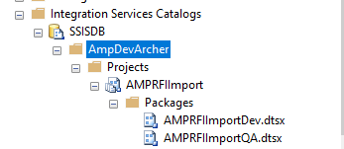

**The AMP SSIS Packages are now deployed**

For scheduling SSIS package by using SQL Agent, and Job ‘s for every 2 hours or as defined in requirement, follow below provided step by step instructions:

**Step 1:** Go to SQL Agent. *Note: SQL agent should be running mode*

**Step 2:** Right click SQL Agent -> Create new job

**Step 3:** Choose the type is SQL server integration - service packages

**Step 4:** Next go to scheduled jobs

1. Code Repository

AMP Portal Code is stored in code Repository:

Code Repository here: <https://escmstash.1dc.com/projects/AMP>

1. API Deployment

In order to move the code into deployment environment, following steps to be followed:

First copy all the files from the folder provided on to the server where the deployment is planned.

The zip file needs to be extracted and all the files should be available in a path, as shown below:

For moving the API published package into the deployment environment, copy the code provided (namely - “Published.zip”) onto the server where the deployment is planned. The zip file needs to be extracted and all the files should be available in the below path:

Drive:\AMP\Published in AMPAPP01 Server.

***Note: 443 PORT to be made available and SSL Cert to be made available (Same need to be ensured for Workday SFTP set up)***

***Create AD login user (Suggested Name: AMP_ProdUser) and provide required access to AppServer, WebServer and Database***

***Update Connection String in APP Configuration settings in API and Web***

***Secure the password using encryption in web.config.***

* **Deploy API in IIS**

Open IIS Manager. Expand your connection and right-click on the Sites folder to add the Website. Give the site name (AMP) and select the application Pool (choose .Net latest, v4.0+).

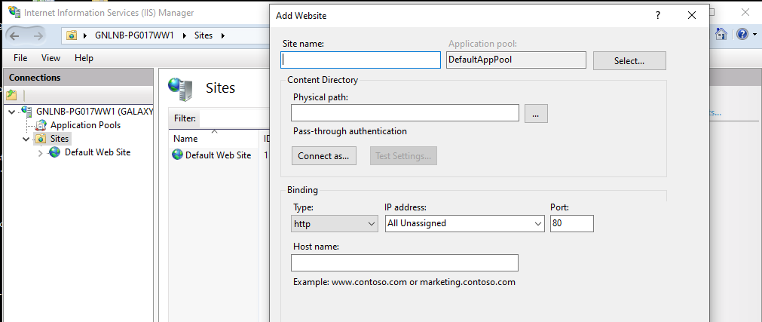

IIS basic setting for AMP API

Open App pool-> Right click🡪go to Advance Setting 🡪 Set Identity of app pool with USER ID which has Metadata and AMP DB access

* Give AMP physical path (***mention path where build is saved)*** (Drive:\AMP \Published) of API project.
* Give the Port number for example ***(88)*** 8088 and then click OK.
* Right-click on your newly added site and Manage Site and click Browse.

It will automatically open the hosted API in the browser. Give the swagger URL “<http://dalwapgst:88/swagger/ui/index.html>”, (URL may change as per Server setting).

Note: Allow IIS_IUSRS’ with full access for the physical path of API to avoid any access issue.

1. API Configuration

* The path for AMP API package is “C:\AMP\Published”,
* Deploy Web.Config file
* Open the ‘appsettings.json’ file in notepad for edit.

The following configuration values are required to be changed accordingly based on user and system settings. The configuration file name is appsettings.json.

* Update Connection String section for Server/Database value as per database details for Meta Data and Self-service DB with server details.
* These are mandatory setting for third party API integration, please update the below values in the appsettings.json file
* "ContentType": "",
* "Accept": "",
* "Authorization": "",
* "UserName": "",
* "Password": "",
* "Timeout": "",

Change below settings value according to your environment

"Domain": {

"Name": [

"LDAP://1DC.COM",

"LDAP://IWPUTL01.corp.checkfree.com/DC=corp,DC=checkfree,DC=com"

],

"BaseUrl": "http://dalwapgst0982:88",

"Job": "http://dalwapgst1080.frms.pvt:80/swagger/index.html"

},

"ApplicationConfiguration": {

"FileTableServerUploadFolder": "\\\\Gxwfsdashdb01\\mssqlserver\\AMPDEV\\AMPDEV"

},

Change Serilog path according to your environment

* Save the appsettings.json file and close.
* Do IIS reset or Apppool reset for the Self-service app in IIS.

1. AMP Dev UI deployment

Below are the steps to deploy the Self-service UI.

* Copy the build file(AMPUI.zip) to the local drive
  + Ex: Drive:\Build
* Unzip and extract the AMPUI file.
* Update index.html file by changing the URL <base href="/"> to <base href="/AMP**/**">***end it with a slash***
* ***Update apiBaseUrl in /asset/appsetting.json according to your enviroment***
* Open Internet Information Services (IIS) manager by typing ‘Inetmgr’ in the Windows search bar
* Once IIS opens expand it.
* Select ‘Sites’, right-click on it, and click on "Add web sites".
* Enter the following details in the Add Website window
  + Site name: AMPUI
  + Physical path: C:\inetpub\wwwroot
  + IP address: <Enter the proper IP address>
  + Port: <Enter a proper port number similar to the above API port#: For example, 8089>
  + Click ‘OK’
* Right-click on the “AMPUI” site and click on "Add Application”.
* Enter the following details in the Add Application window
  + Alias: AMP
  + Physical path: (***mention path where build is saved)*** C:\\ AMPUI
  + Click ‘OK’
* Enable ‘Directory Browsing’.
  + Select the ‘AMPUI’ site. In Features View, double-click Directory Browsing. In the Actions pane, click Enable if the Directory Browsing feature is disabled.
* Open App pool-> ***(select Application name)*** Right click🡪go to Advance Setting 🡪 Set Identity of app pool with ***(1dc\User ID)*** user Id which has Metadata and Self Service DB access
* Allow IIS_IUSRS’ with full access for the physical path of UI to avoid any access issue.
* Right-click on the ***(Application)*** site, go to Manage Application, and click on "Browse" to browse the application.
* IIS setting for AMP Dev UI ***(provide path as – select application -> click on Basic Settings -> Click Select on Edit Site pane) put this bullet point after Physical Path***
* User can login to the AMP Dev portal with either 1DC(Lan ID) or FEAD ID by using the below screen

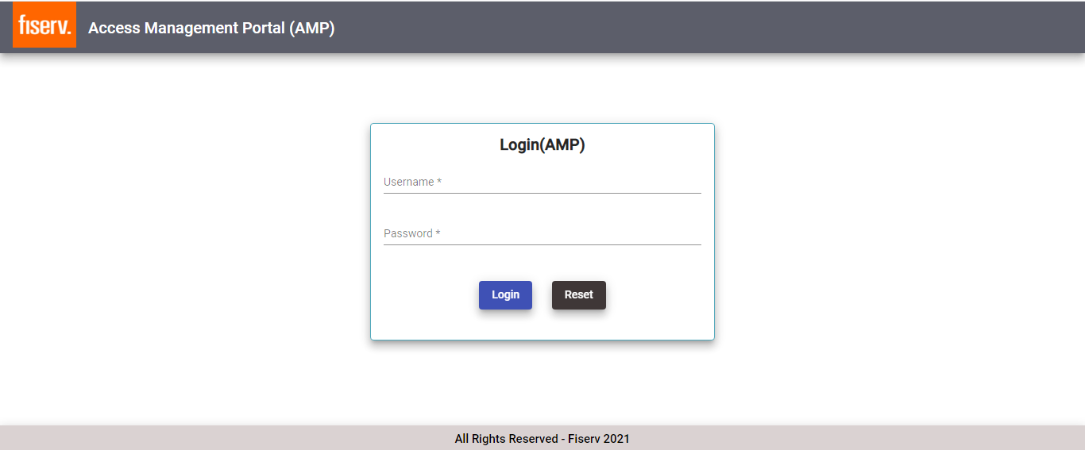

1. AMP Portal Configuration

<To be updated in next milestone>

|  |  |
| --- | --- |
| **Configuration Specifications** | |
| Config File Name: |  |
| Config File Path: |  |
|  | |
|  |  |
|  |  |
|  |  |

1. AMP Job Scheduling

In order to move the code into deployment environment, following steps to be followed:

First copy all the files from the folder provided on to the server where the deployment is planned.

The zip file needs to be extracted and all the files should be available in a path, as shown below:

For moving the Job published package into the deployment environment, copy the code provided (namely - “Published.zip”) onto the server where the deployment is planned. The zip file needs to be extracted and all the files should be available in the below path:

Drive:\AMP\Published in AMPAPP01 Sever.

* **Deploy Job in IIS**

Open IIS Manager. Expand your connection and right-click on the Sites folder to add the Website. Give the site name (AMP) and select the application Pool (choose .Net latest, v4.0+).

IIS basic setting for AMP API

Open App pool-> Right click🡪go to Advance Setting 🡪 Set Identity of app pool with USER ID which has Metadata and AMP DB access

* Give AMP physical path (***mention path where build is saved)*** (C:\AMP \Published) of API project.
* Give the Port number for example ***(88)*** 8088 and then click OK.
* Right-click on your newly added site and Manage Site and click Browse.

It will automatically open the hosted API in the browser. Give the swagger URL “ [http://dalwapgst1080.frms.pvt:88/swagger/index.html](http://dalwapgst:88/swagger/ui/index.html)”, (URL may change as per Server setting).

Note: Allow IIS_IUSRS’ with full access for the physical path of API to avoid any access issue.

1. AMP Job Configuration

* The path for Self Service package is “C:\AMP\Published”,
* Open the ‘appsettings.json’ file in notepad for edit.

The following configuration values are required to be changed accordingly based on user and system settings. The configuration file name is appsettings.json.

* Update Connection String section for Server/Database value as per database details for Meta Data and Self-service DB with server details.
* Update the following mandatory setting
  + - "IntervalInMinutes": "02"
    - "Hours": "0"
    - "Minutes": "0
    - "BaseUrl": <http://dalwapgst1080.frms.pvt:88>
    - Change Serilog setting according to your environment
* Save the appsettings.json file and close.
* Do IIS reset or Apppool reset for the Self-service app in IIS.

1. Appendix

Appendix A

**SFTP info for Workday to Galaxe Workday feed**

1.Install Java from software center

2.Download: SSH key authentication send through email

3.Download Firewall(firvAuth) using Fiserv credentials using fuel link page

4.Provide your 1DC credentials and get authorized from firewall

5.Using below input details open firewall for sftp

Input: Open firewall for sftp and Sftp connection

Sftp: test-gw-na.1dc.com

Port: 6522

Username: UA10746-APM6460

Authentication: SSH Key Authentication

5.Open Command Prompt and provide commands to download file from Sftp. please refer screen shot

**Output: Download Workday file**

Directory: available

Sample file Name: GALAOU01.WorkdayDownload20211116072104.csv

File Extension: CSV

Filename: GALAOU01.WorkdayDownload20211116042654.csv

1. Assumptions

NA

1. Revision History

|  |  |  |  |  |  |
| --- | --- | --- | --- | --- | --- |
| Date | Version | Created By | Reviewed By | Approved By | Description of change |
| 10/26/2021 | 0.1 | GalaxE | GalaxE | Fiserv | Initial draft version |